Merging Public Opinion Information and Stock Numerical Data for Stock Trend Prediction Based on Deep Learning

Geng Lvª, Jianjiang Cui*^{b}
ª School of Information Science and Engineering, Northeastern University, NO. 3-11, Wenhua Road, Heping District, Shenyang, 110819, China; ^{b} School of Information Science and Engineering, Northeastern University, NO. 3-11, Wenhua Road, Heping District, Shenyang, 110819, China

Abstract

Unlike other stock markets participants, the participants in China mainland are composed of individual investors, which account for 82% of the trading volume of the stock market. The decision-making basis of individual investors is mainly public opinion and recent stock prices. Therefore, the public opinion on professional stock social sites has an important impact on the decision of individual investors, which in turn affects the trend of the stock market. However, the previous stock market forecasting methods mostly ignored the influence of public opinion information on the market. For this reason, this paper proposes a novel framework to predict the stock trend by using both public opinion and stock numerical data. The original contributions of this paper include stock commentary word embedding model based on the stock comment text data crawled from https://xueqiu.com through two-stage training and LSTM-CNN layered model based on the improved self-attention mechanism. Two main experiments are conducted: the first experiment extract stock commentary word embedding, and the second experiment forecasts the stock price trends of Shanghai and Shenzhen A-share market. Results show that: 1)LSTM-CNN layered model is better than previous methods; 2)The combination of public opinion information and numerical data can improve the performance of the model; 3)Stock commentary word embedding model is better than pre-training word embedding model; 4) The longer the data span, the better the stock forecasting model will perform.

Keywords: Deep learning, natural language processing, stock prediction, public opinion information, stock numerical information

INTRODUCTION
The stock market is one of the most important components of a country's economy. Its operation can reflect the domestic economic trend to a certain extent, as well as the development trend of an industry. With the continuous development of China's stock market, investors participating in the stock market are also increasing year by year. However, individual investors are often unable to accurately grasp market trends, are prone to chasing up and down, frequent trading, and have characteristics such as overconfidence(X. Xu et al. 2008), overreaction and lack of reaction, and herd behavior, resulting in frequent stock market volatility. At the same time, the scope of influence of the Internet continues to expand. In the social platform for the stock market, stock investors often communicate with each other and express their opinions on stock market trends, economic policies and news, so the public opinion information on the network has an important impact on the decision-making of individual investors (Medovikov 2016). Therefore, constructing a reasonable stock forecasting model not only guides individual investors to invest, but also helps stabilize the stock market.
Early stock forecasting models mainly used methods such as time series modeling and machine learning. The time series method believes that the running curve of the stock market has certain regularity(Box G E P et al. 2010), so the historical trend can be used to obtain future trends. The classical algorithm of the method is the ARIMA model (A. A. Ariyo et al 2014). However, the time series method is proposed to highlight the time factor without considering the influence of external factors. In the machine learning method, White(1988) used Back Propagation(BP) neural network to predict IBM's stock daily return rate. It was limited by the computing power at that time. The model failed to reach a more accurate level. Later, researchers applied many machine learning algorithms to stock forecasting, such as TOPIX (Kimoto T, Asakawa K et al. 1990), ARIMA-BP (Fernandez-Rodrıguez F et al. 2000), SVR(Kyoung-jae Kim 2003), Random forest (Zhang J et al. 2018), Wavelet denoising (Sui X S et al. 2008)and so on. Although these methods have achieved better results than before, but relying solely on stock prices can not accurately predict the trend of stocks, while the machine learning model feature extraction ability is weak, unable to capture deeper information in the stock market, to further improve the forecast accuracy.
In 2006, Professor Hinton of the University of Toronto first proposed the concept of deep learning. The structure of deep learning is a multi-layer neural network, which can form a concept level by using multiple representation levels corresponding to different abstract levels, which can solve nonlinear problems more effectively than traditional methods (L. Deng et al. 2014;X.-W. Chen et al. 2014; X. Jin, J. Shao et al. 2016). In 2014, Kuremoto T et al.(2014) used a restricted Boltzmann machine to construct a time-series prediction model for deep confidence networks.In 2016, Dixon M F et al. (2016) proposed financial market predictions for deep neural networks based on deep learning. Deep learning is good at handling large amounts of unstructured data, extracting abstract features and identifying hidden relationships in financial markets(E. Chong et al. 2017), which was not possible with previous methods.
At the same time, with the development of natural language processing technology, scholars began to study the impact of text data on financial market trends.Y. Zhang et al. (2016) and M. Dang et al. (2016) used the daily comment text data into specific numerical indicators, and predicted based on Long Short-Term Memory neural networks(LSTM) and SVR respectively. Guo et al. (2017) confirmed that when the sentiment index in the paradox is high, the public opinion data can be used to predict the stock market. Zhang et al. (2018) showed that there is a correlation between the number of comment texts in the xueqiu network and the turnover rate of the day in the stock market. A two-category classification prediction model is constructed based on the textual sentiment index and the user-oriented directed graph. Huang et al. (2018) based on Zhang's research, added LSTM based on tensor decomposition, which improved performance compared with previous models.
Based on the above analyses and evaluations, we proposes a new method for predicting stock trends through deep learning and natural language processing techniques to analyze the data of previous days. The overall framework is shown in Figure 1. Our works can be summarized as follows:
1. Two-stage training on the emotional tendency words in the financial field improves the quality of the emotional tendency word embedding .
2. A method of combining financial review text data with stock numerical data is proposed.
3. The self-attention mechanism is improved, and a LSTM-CNN layered model based on improved self-attention mechanism is proposed, which can directly model large-scale comment texts.
4. We propose a novel stock forecasting framework ,which can use multiple days of data to predict the next day's stock trends.
The rest of the paper is organized as follows. Section 2 reviews the word embedding , the related work of the deep learning network. In Section 3, we introduced the acquisition and processing of data, as well as the two-stage word embedding . In Section 4, we present the proposed model and explain each module in detail. In Section 5, we present the experimental results and make a comparative analysis. In Section 6, we give conclusions and directions for further research in the future.

RELATED WORK

Word embedding
In order to solve the problem that text data cannot be directly processed by a computer, a word embedding model is used to reasonably represent text data as a digital representation. The word embedding model originated from the neuro-probabilistic language model proposed by Bengio et al. (Bengio Y, Schwenk H, Senécal J, et al. Neural Probabilistic Language Models[J]. Journal of Machine Learning Research, 2003, 3(6):1137-1155.). Based on this model, Mikolov proposed the Word2Vec model (Mikolov T, Sutskever I, Chen K, et al. “Distributed representations of words and phrases and their compositionality[C]”// International Conference on Neural Information Processing Systems. Curran Associates Inc. 2013:3111-3119.; Mikolov T, Chen K, Corrado G, et al. “Efficient estimation of word representations in vector space[J]”. arXiv preprint arXiv:1301.3781, (2013).)and the GloVe model (Pennington J, Socher R, Manning C. Glove: Global Vectors for Word Representation[C]// Conference on Empirical Methods in Natural Language Processing. 2014:1532-1543.). The Word2Vec model is a distributed word embedding model, which mainly includes two frameworks, namely the Continuous Bag-of-words Model (CBOW) and the Continuous Skip-gram Model (Skip-gram). The CBOW model predicts the target word based on the context of the target word, and the skip-gram model uses the target word to map the layer to predict the context word. The glove directly uses the gradient descent method to learn the word embedding. GloVe combines the global statistical information with the local context window, and does not use the neural network model during the training process, which makes the training speed can be greatly improved. Word2vec and GloVe are very effective in NLP problems (J. Pennington, R. Socher, and C. D. Manning, ‘‘GloVe: Global vectors for word representation,’’ in Proc. Conf. Empirical Methods Natural Lang.Process. (EMNLP), 2014, pp. 1–12.), but the word embedding that is only trained once has not achieved the desired effect in the financial field, so it should be used for secondary training to apply it to the financial field. Based on Yu L C , Wang J , Lai K R , et al. “Refining Word Embeddings Using Intensity Scores for Sentiment Analysis[J]”. IEEE/ACM Transactions on Audio, Speech, and Language Processing, PP(99):1-1 (2017).), we propose a method based on the constructed sentiment dictionary to propose a two-stage training of word embedding.

Deep learning network
Convolutional neural network (CNN) was first proposed by LeCun et al. (1989) and was a neural network structure specifically designed to process data with parallel features, such as time series data and image data. Recurrent Neural Network (RNN) was a kind of neural network structure dedicated to processing sequence type data. Sequence data is usually a data structure with chronological or logical order. RNN has been shown to be more efficient than CNN in text and speech analysis (S. Hochreiter et al. 1997), but there was a problem with the model structure of RNN (S. Hochreiter 1998): In gradient back propagation, RNN was prone to gradient disappearance or gradient explosion. GRU (Gated Recurrent Unit) (K. Cho et al. 2014) and LSTM (Long Short-Term Memory) were proposed as the solution for the problem as they have the ability to keep memory from previous activations rather than replacing the entire activation like RNN. LSTM internally designed three door structures to solve long-term dependencies. Compared to LSTM, GRU removes the unit state and reduces a control gate. Moreover, GRU was computationally more effective than LSTM as pointed out in (K. Cho et al. 2014). It has been confirmed that the state at a certain moment is not only related to the historical state, but also related to the future state. Based on this conclusion, Schuster et al. (1997) proposed a bidirectional cyclic neural network to obtain information on historical and future states. Lin et al. (2017) studied and proposed a feature combination method based on LSTM neural network, called Self-Attentive mechanism. Its advantage is that the model can control the weight of each moment through an additional single-layer neural network, which in turn controls how much information is used at each moment in the model generation decision. In most application scenarios, including sentiment analysis, the self-attention mechanism model achieves near-best results. In the modeling of large-scale long texts, Yang et al. (2016) studied and proposed Hierarchical Attention Networks (HAN). HAN has a strong ability to model very long texts and has a good performance in sentiment analysis. The data structure of our text is very consistent with the HAN structure, so we use the layered attention network to construct the financial text model and the improved self-attention mechanism can better retain the information carried by the original vector.

DATA AND TWO-STAGE WORD EMBEDDING

Data collection
Studies have shown that social commentary has an impact on stock movements, so this article collected commentary text data as extended data for numerical data. The source of the comment text is https://xueqiu.com. It is a professional investment social platform where users can post comments or share portfolios. This website has a huge user base, and it has a greater influence in the investment market than other platforms. We have got 3,265 shares of A-shares from the Shanghai and Shenzhen stock markets, and obtained a total of 110,063,010 texts, spanning from April 1, 2018 to July 31, 2018.
In order to obtain more accurate predictions, the prediction model requires certain numerical feature of the stock. The source of the numerical data we use is the Tushare interface package. Tushare is an open source Python financial data interface package that provides daily stock quotes, replay factors, stop and resume information, daily fundamental indicators, and company financial data and trading market data for Shanghai and Shenzhen stocks. According to the data returned by Tushare, we selected 13 numerical characteristics such as opening price, highest price, turnover rate and market sales rate.

Data processing
A participle is a process of dividing a string into substrings, and the substrings need to satisfy the condition of independent idioms. Chinese is different from English. Chinese does not use delimiters to segment words in sentences. We use Python-based word segmentation toolkit jieba to segment words. Text data collected directly on the network will have some noise, such as special symbols, URLs, meaningless fields, expressions, pictures, etc. To ensure the accuracy of word segmentation, this paper has filtered non-text data through regular matching in the data crawling phase.
After text segmentation and text data cleaning, we can use text data to build the training set. Length of text data are mostly distributed between 120 and 180 and we limit the length of each text to 128 words, including punctuation. If the length of a long text is greater than 128, it will be divided into multiple segments; for texts less than 128 in length, a zero padding operation is required to make all texts the same length. We selected 64 texts as training data in each natural day. For the numerical data, we selected 13 categories of features such as opening price, highest price, turnover rate, and sales rate, and gave the label according to the up and downs of the next day's stock.
The composition of the final data is shown in Figure 1. One data contains t (t∈ [1,3,5]) data units. According to the value, the text has 3 data sets, t takes 1 for the data unit of the previous day using the predicted time, t takes 3 for the data unit of the first three days of the predicted time, and so on. The last digit in the data represents the stock movement at the forecasted moment.
Fig. 1 Format of training set

Two-stage word embedding
In order to obtain a word embedding suitable for the financial field, we first perform the first-stage word embedding training on the pre-processed text data. The main parameter settings used in the training process are shown in Table 1 below. The window width in Gensim refers to the context window used in Skip-gram, which means that two values are taken around the center word; the window width in the GloVe model is a co-occurrence window for statistical co-occurrence, so the window width is larger.
Table 1 Main parameters
Type | embedding dimension | Learning rate | Epoch | Window width
Word2vec | 300 | 0.025 | 5 | 5
GloVe | 300 | 0.25 | 5 | 10
After the above training process, this paper got two different word embedding models. This paper takes three representative words in the financial field as an example to analyze the difference in performance between the two models. The three words selected are “rise”, “flat” and “market”. After comparing the two models on the basis of three words, we find that the performance of the Word2Vec model is significantly better than the GloVe model, so we select the word embedding trained by the Word2Vec model as the input of the subsequent model.
In order to make the trained word embedding have better performance in the financial field , we need to fine tune the trained word embedding model. We collected 132 trend words that are most relevant to the ups and downs of stocks. They are divided into 53 words of optimistic tendency, 34 words of neutral tendency and 45 words of pessimistic tendency.
We propose a new algorithm for the two-stage word embedding: the algorithm is divided into two parts. First, for the target word, the k words closest to the target word are selected in the word embedding obtained in the first training. In this example, k is 10 and the measurement standard is cosine similarity. The second step reorders the obtained vocabulary. If the target words are optimistic, they are reordered according to “optimistic | neutral | pessimistic”; if the target words are neutral, they are reordered according to “neutral | pessimistic | optimistic”; If the target words are pessimistic, reorder them according to "pessimism | neutrality | optimism". After reordering, the model constructs an optimization problem and seeks a second best solution. The objective function of the optimization problem is (1). The selection of neighbors can be chosen from all words, not necessarily in a target word set of size 132.Weight for neighbor words , by sorting category, value of the first category and the second category is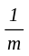 , m is its order in the entire sequence. Value of the third category is .
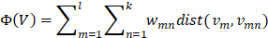 (1)
is the number of target words, is the number of neighbors set in the model, is the target word, is the neighbor of the target word, is the weight of the neighbor word, and its value is the reciprocal of a sorted value in word list. 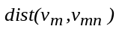is the distance between the target word and the neighbor word(2). D represents the word embedding dimension
(2)
If the distance between the adjusted word embedding and the word embedding before adjustment is large, the semantics of the word embedding may change greatly; to prevent this from happening, the penalty function is added to the objective function of the algorithm, and the penalty item is added. The goal is to make the variation of the word embedding not too large during each iteration. The objective function expression after adding the penalty is (3):
(3)
and are hyperparameters, used to adjust the proportion of penalty terms to the original objective function. represents a word embedding that iterates to times, represents a word embedding that iterates to times. is the iterative step size, is the gradient at which the objective function is at . Our process of reordering the 10 nearest neighbors of "rise" and the weights are shown in Figure 2. “Rise” represents optimistic tendencies and “Fall” represents pessimistic tendencies.
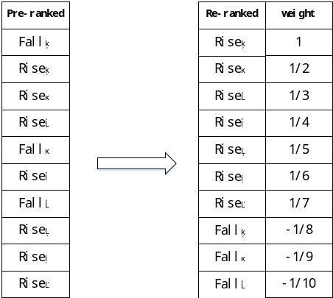
Fig. 2 Reordering for nearest neighbor words of "rise"
Figure 3 shows the spatial relative relationship between “rise” and the first 10 nearest neighbors in the model of initial training of word vectors. Figure 4 shows the spatial relative relationship after the two-stage training of word vectors. The points shown in the figure are 300 dimensions. The word embedding uses the PCA to reduce the dimension to the 2-dimensional space. Target word is “rise” represented by “⚪”. “ * ” represents heterogeneous words and “ + ” represents similar words .It can be seen that the target word is closer to the same category after the second-stage training than the result of the initial training.
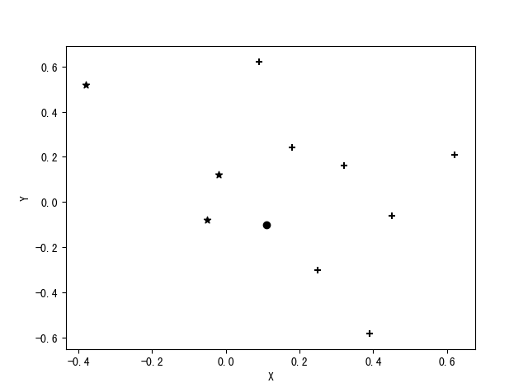
Fig. 3 Position of the target word and the 10 nearest neighbors after the initial training
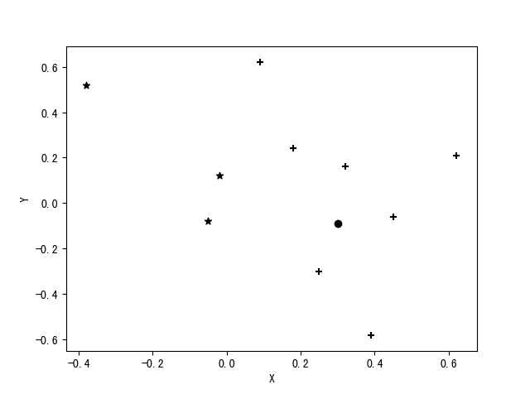
Fig. 4 Position of target word and 10 nearest neighbors after the second-stage training

MODEL

Financial text model

4.1.1 BiLSTM-CNN hierarchical network
The text data in this paper is long text data, and the amount of data is large. It is difficult to model using ordinary two-way LSTM. In order to solve the problem of long text modeling, we stack two bidirectional LSTMs based on the self-attention mechanism. The bottom part is responsible for modeling the words in each text segment, and the upper part is responsible for the paragraph representation embedding obtained from the bottom part. Modeling. In response to the slow calculation of LSTM, we replace some or all of the LSTM modules in the layered attention network with CNN networks . Since the text segments are in a side-by-side relationship and do not have a temporal or logical relationship between words in a text segment, it is natural to think of replacing the upper LSTM with the CNN structure. This paper refers to this model as a two-way LSTM and CNN layered model based on self-attention mechanism in Figure 5.
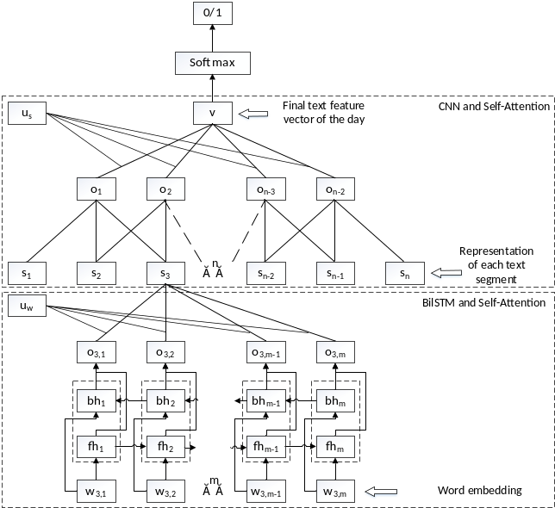
Fig. 5 LSTM-CNN hierarchical model
The parameters of the model are as follows: convolution kernel is 3*600, number of convolution kernels is 128, batch size is 32, LSTM dimension is 300, feature embedding dimension is 128, learning rate is 0.0003. The convolution process is one-way sliding, and no zero embedding filling is performed on both sides. The comparison results of the model are shown in Table 2. We found that the LSTM-CNN model still achieved the desired accuracy when the training time was greatly reduced.
Table 2 Model representation and running time
Model | Time for one epoch | Accuracy
LSTM-LSTM | 78min | 54.65%
GRU-GRU | 70min | 54.21%
LSTM-CNN | 55min | 54.51%
CNN-LSTM | 43min | 54.02%
CNN-CNN | 37min | 53.39%

4.1.2 Improved self-attention mechanism
Inspired by shortcut connection(Wang T , Sun M , Hu K . Dilated Deep Residual Network for Image Denoising[J]. (2017).), we proposed a method to improve the mechanism of self-attention (Vaswani A , Shazeer N , Parmar N , et al. Attention Is All You Need[J]. (2017).) and the improved structure is shown in Figure 6. In the original method, and are respectively obtained after the original embedding is processed by LSTM units with two different directions, as shown in the two dashed boxes in the figure. Such operation loses the information carried by the original embedding value.
This paper proposes to supplement the feature embedding obtained after processing. The specific method is to directly connect the original embedding of each moment with the feature embedding of each moment by skipping the LSTM unit, and conduct subsequent processing based on the connected vector, such as the weighted sum after calculating the attention weight.The comparison results of the improved self-attention mechanism are shown in Table 3.
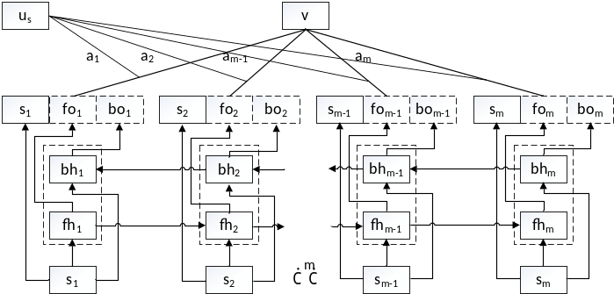
Fig. 6 Improved self-attention mechanism

Table 3 Improved self-attention mechanism performance
Model | Time for one epoch | Accuracy
LSTM-CNN | 55min | 54.51%
LSTM-CNN Based Improved Self-attention | 56min | 54.96%

Numerical data model
Add a blank line above and below section headings and between paragraphs. Avoid headings or one-line paragraphs at the top or bottom of a page by using page breaks or extra blank lines. One method to preserve page breaks is to make the bottom margin a little larger than the specifications. Indentation is optional. This spacing is automatic if you are using the SPIE "section" styles in Word.
The original numerical data obtained by us are not consistent in dimension, so it needs to be normalized or standardized to dimension first. The Normalization operation was chosen to be dimensionless and the Batch Normalization Layer (BN) structure in the neural network was used to achieve this step. The calculation formula of standardized value is (4)(5)(6):
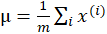 (4)
(5)
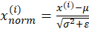 (6)
Where represents different data in the same batch, represents the number of data in the batch, is the mean value of data in this batch, is the variance, = to prevent the value of 0 in the denominator.Through the above calculation, the output value of this layer can be converted into a normal distribution subject to 0 mean and 1 variance.
Numerical data for a 13 dimension vector, without coding with complex structure, the first thing we will adopt batch of standardized financial numerical data layer, through the two layer width of full connection layer processing, eventually generate numerical data characteristic vector. The model structure is shown in Figure 7.
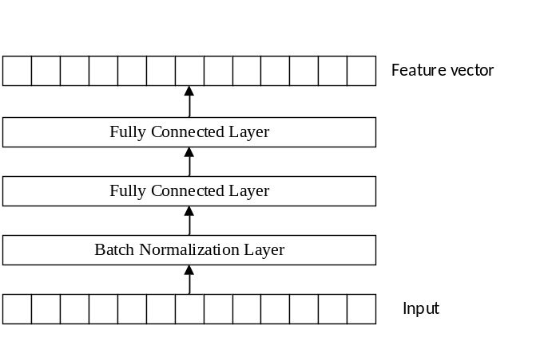
Fig. 7 Model of the numerical data section

Overall forescating model
The final prediction model of this paper is shown in Figure 8, where the lowest module is a bidirectional LSTM neural network based on self-attention, which is used to process each text segment and finally generate the embedding representation of each text segment. represents the number of words in the text segment, and the value selected here is 128.
The middle and lower layers process the set of text segment vectors, use convolutional neural network to carry out convolution operation, and use self-attention mechanism to reduce dimension of the generated embedding set, where is the number of text segments in the set, and the value selected here is 64. This part, together with the bottom module, forms the text processing model. Another part of the middle and bottom layer processes the numerical data and splits the resulting text feature embedding with the numerical feature embedding to obtain the mixed feature embedding of the final day.
The upper and middle layers process the feature vector of each date, represents the number of days contained in the data. Since the data between different dates meet the temporal sequence relationship, the model is a double-layer stacked bidirectional LSTM neural network, so it has a total of 4 layers, and there is no connection between the forward transfer layer and the reverse transfer layer. Both the first layer of forward transfer and the first layer of reverse transfer are processed by HighWay network in order to solve the problem of training difficulty and poor effect caused by model stack. Finally, the feature vector obtained at each moment is spliced horizontally to obtain the final feature vector.
The top layer forecasts the market trend of the next day, and then uses softmax to process the final feature embedding to get tomorrow's stock trend, namely, up or down. The parameters of each part of the model are shown in Table 4.

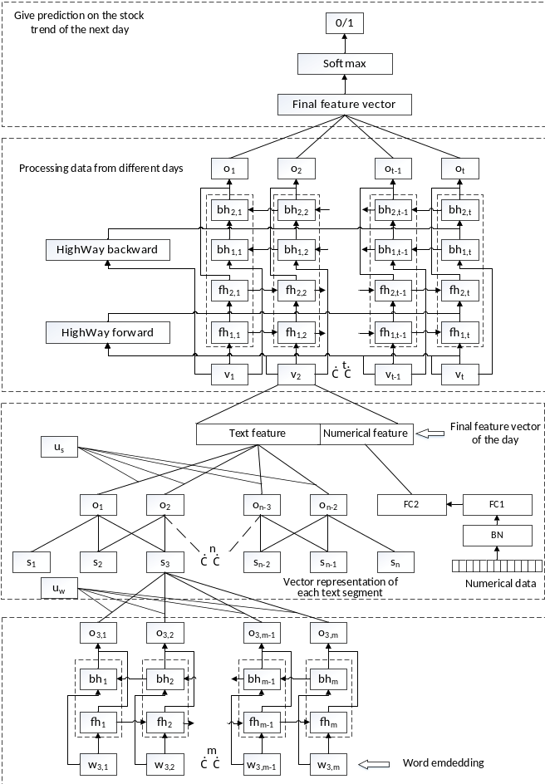
Fig. 8 Overall prediction model
Table 4 Main parameter values
Parameter | Value
Word embedding dimension | 300
Text_LSTM dimension | 300
Number of words in text segment | 128
Text attention layer dimension | 256
Text segment embedding representation | 900
Number of text segments | 64
Convolution kernel size | 3*900
Number of convolution kernels | 128
Batch regularization dimension | 13
Fully connected network dimension | 13
Text segment attention layer dimension | 128
Final single day feature | 141
Data days | 3,5,7
Daily data LSTM dimension | 141
Final feature embedding dimension | 141*t
Number of categories | 2

EXPERIMENT

Model performance evaluation criteria
The deep learning framework used in this paper is the GPU version of Tensorflow, the programming language is python3.6, the operating system is Windows10, and the graphics card model is GTX1080ti.
The loss function of the model uses the cross entropy loss function(7), and in order to mitigate the over-fitting risk of the model, we use the L2 regularization term.
(7)
Where 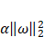 is the L2 regularization term and is the weighting factor, which is used to control the ratio of the loss function to the regularization in the control formula. The value in this paper is 0.001, which represents the weight value in the model.
The model evaluation criteria in this paper are measured by the two-category correct rate and the F1 value. The correct rate is defined (8):
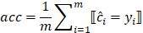 (8)
Where represents the number of samples for this prediction, represents the prediction category of the first sample, represents the real category of the sample, operator represents the value 1 when the expression is established, and 0 when not satisfied. The F1 value is an indicator used to measure the performance of the two-category model, which takes into account the accuracy and recall rate of the model. The formula for calculating the F1 value is defined(9):
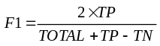 (9)
represents the total number of samples, and ,TN represent the correct classification of the corresponding class.
In the training process, we also used some techniques to improve the performance of the model. Early Stopping: If the test set error is not reduced during a certain training period, the model stored at the time when the last training set error is reduced is taken as the final model, and the training process is stopped. The time period set in this paper is 5000 steps. Dropout: Dropout (Srivastava N, Hinton G, Krizhevsky A, et al. Dropout: a simple way to prevent neural networks from overfitting[J]. Journal of Machine Learning Research, 15(1):1929-1958 (2014).) is a way to reduce the degree of over-fitting of the model. In this paper, Dropout is applied to the output layer of only two fully connected layers and all LSTM units, with 10% of neurons missing in each living layer. Clipping Gradient: In the process of loss function optimization, there may be a situation where the gradient value is large and the step size of the update process is too large, or the hypersurface of the loss function has a “cliff” area, which makes it impossible to reach a minimum point. For this reason, the gradient embedding is divided element by element by the norm of the gradient, and the processed gradient is the truncated gradient, which can effectively solve the above two problems.

Comparison of experimental results
5.2.1 Differences between different time data results
We generated three different data sets according to different prediction times. The length of time is based on 1, 3, and 5 days before prediction. The detailed statistics of the three types of data are shown in Table 5.
Table 5 Statistical characteristics of three types of data
Data duration | Total number of samples | Positive proportion
One day | 203742 | 50.6%
Three days | 198549 | 50.1%
Five days | 175329 | 50.4%
The results in the Table 6 can be obtained. As the data duration increases, the time of single round training increases almost linearly. In terms of model performance, the correct rate of 5 days data training is the best, but the training time is also the highest . The 3 days data and the 5 days data are not much different in terms of correctness; the performance of the 1-day duration data is significantly lower than that of the other two durations. The difference between the F1 value and the correct rate in this round of experiments is not large, indicating that the model does not have an over-fitting to the test set.

Table 6 Experimental results of three types of data
Data duration | Time for one epoch | Accuracy | F1 scores
One day | 57min | 56.3% | 55.6%
Three days | 83min | 58.8% | 56.4%
Five days | 102min | 59.2% | 57.3%

5.2.2 The influence of word embedding two-stage training on prediction results
We experimented separately on two different word vectors and compared the performance differences between the two experiments. The data used in the experiment was three days long, and the experimental results are shown in Table 7. It can be seen from the experimental results that the word embedding after the two-stage training improves the test set correct rate and the F1 value and reduces the training time compared to the pre-trained word vector. The experiment proves the effectiveness of the two-stage word embedding training.

Table 7 Experimental results of two word vectors
Word embedding | Time for one epoch | Accuracy | F1
Pre-word embedding | 83min | 57.2% | 55.7%
Two-stage embedding | 80min | 58.8% | 56.4%

5.2.3 The impact of text data and numerical data on forecast results
In order to compare which data in the text data and the numerical data has a greater influence on the prediction result of the model, on the basis of the three-day data, we only experimented with text data and numerical data. When only text data is used, the numerical data model in the hybrid model is removed, and the neural network dimension of the affected position is sequentially reduced; when the numerical data is used, the text data model in the mixed model is removed, and the bottom and middle portions of the partial model are deleted. Part of the structure in the lower layer. The experimental results are shown in Table 8. The experimental results show that the prediction model using only text is better than the numerical model data, which indicating that the numerical data provides less information to the prediction model than the text data.

Table 8 Experimental results of single type data
Data type | Time for one epoch | Accuracy | F1
both | 83min | 58.8% | 56.4%
Only text data | 78min | 56.1% | 54.8%
Only numerical data | 10min | 52.2% | 52.5%
5.2.4 The effect of sparse text on prediction results
Since the stocks in the market are not inconsistent, the stocks with lower attention are less, that is, there are fewer than 64 daily texts of some stocks. For these cases, this article will use the 0 embedding to fill up to 64 texts during processing, resulting in the problem of sparse text data. Since the processing of sparse data introduces noise into the training process, sparse data usually severely degrades the performance of the model. We will analyze the impact of sparse data on the performance of predictive models in this paper.
This round of experiments was based on 3 days of data. First, the text data is filtered. If the number of texts on the day does not reach 50% of the capacity, that is 32, all the data including the current day will be discarded. The results obtained by training using the filtered data are shown in Table 9.

Table 9 Experimental results of filtered data
Data type | Number of samples | Accuracy | F1
Before filtering | 198549 | 58.8% | 56.4%
After filtering | 63427 | 62.7% | 63.1%

After filtering the text data, about two-thirds of the samples were discarded. The experimental results show that after using the filtered data, the performance of the model is greatly improved compared with the data before filtering, that is, the sparse text data has a great influence on the performance of the model.

5.2.5 Comparison with previous methods
We compared the performance of different models on the Shanghai A-share Composite Index.Although the training data and input data time spans of different models are different, the goal of the model is to predict the trend of stocks, so we can use the accuracy rate to compare the quality of the model to some extent.The comparison results of stock forecasting methods are shown in Figure 9.
The traditional stock forecasting methods AR and ESTAR (Chen Q A , Li C D . Comparison of Forecasting Performance of AR, STAR and ANN Models on the Chinese Stock Market Index[C]// International Symposium on Neural Networks. Springer, Berlin, Heidelberg, (2006).) have accuracy rates of 50.3%, 52.4% respectively. The accuracy of the MLP, ELSTM (Pang, X., Zhou, Y., Wang, P., Lin, W. and Chang, V. “Stock Market Prediction based on Deep Long Short Term Memory Neural Network”. In Proceedings of the 3rd International Conference on Complexity, Future Information Systems and Risk (COMPLEXIS 2018), pp. 102-10) based on neural networks are 54.8% and 57.2%.The accuracy of the our model are 59.2% and 63.7%(After filtering).It is clear that Shanghai A-share Composite Index could be predicted by neural networks more accurate than traditional methods and LSTM-CNN proposed in this paper can extract the information in the text data better than others stock forecasting methods.

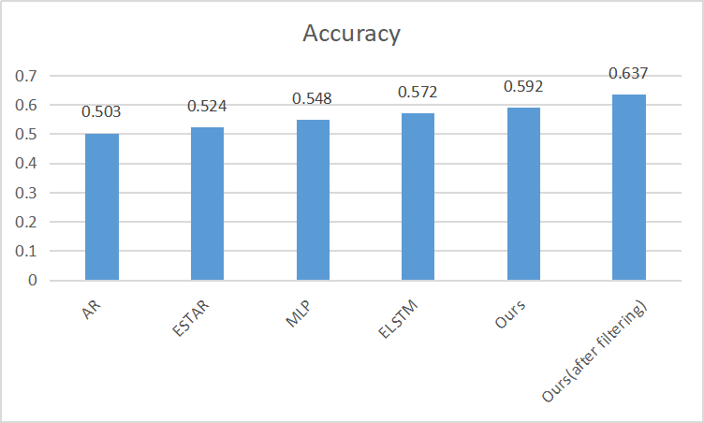
Fig.9 Comparison with previous methods

CONCLUSION
The experimental results show that the model performs best on the 5th data, and the accuracy of stock prediction are 59.2% and 63.7%(after filtering). Our model has excellent performance in stock forecasting.It is proved that the two-stage training of word embedding can improve the correct rate of the test set of the model; the experimental results show that the text data provides more information than the numerical data to the prediction model; finally we discusses the influence of sparse text data on the performance of the prediction model. It shows that the model performance is significantly improved when the text after removing the sparse data is used for prediction.

References
- X. Xu and Z. Lu, “Notice of Retraction Research on the Mental Mechanism of Chinese Individual Investor,” 2008 4th International Conference on Wireless Communications, Networking and Mobile Computing, Dalian, 2008, pp. 1-4.
- Medovikov, “When does the stock market listen to economic news? New evidence from copulas and news wires,” J. Banking Finance, vol. 65,pp. 27–40, Apr. (2016).
- Box G E P, Jenkins G M. “Time Series Analysis: Forecasting and Control[J]”. Journal of Time, 2010, 31(4):303-303.
- A. A. Ariyo, A. O. Adewumi and C. K. Ayo, "Stock Price Prediction Using the ARIMA Model," 2014 UKSim-AMSS 16th International Conference on Computer Modelling and Simulation, Cambridge, 2014, pp. 106-112.
- White H. “Economic prediction using neural networks: the case of IBM daily stock returns[C]”// IEEE International Conference on Neural Networks. IEEE, 1988:451-458 vol.2.
- Kimoto T, Asakawa K, Yoda M, et al. “Stock market prediction system with modular neural networks[C]// IJCNN International Joint Conference on Neural Networks”. IEEE, 1990:1-6 vol.1.
- Fernandez-Rodrıguez F, Gonzalez-Martel C, Sosvilla-Rivero S. “On the profitability of technical trading rules based on artificial neural networks:: Evidence from the Madrid stock market[J]”. Economics letters, 2000, 69(1): 89-94.
- Kyoung-jae Kim. “Financial time series forecasting using support vector machines[J]”. Neurocomputing, 2003, 55(1):307-319.
- Zhang J, Cui S, Xu Y, et al. “A novel data-driven stock price trend prediction system[J]”. Expert Systems with Applications, 2018, 97: 60-69.
- Sui X S, Qi Z Y, Yu D R, et al. “A Novel Feature Selection Approach Using Classification Complexity for SVM of Stock Market Trend Prediction[C]”// International Conference on Management Science and Engineering. IEEE, 2008:1654-1659.
- Kuremoto T, Kimura S, Kobayashi K, et al. “Time series forecasting using a deep belief network with restricted Boltzmann machines[J]”. Neurocomputing, 2014, 137(15):47-56.
- L. Deng and D. Yu, “Deep learning: Methods and applications,”Found. Trends Signal Process., vol. 7, nos.
3–4, pp. 197–387,Jun. (2014).
- X.-W. Chen and X. Lin “Big data deep learning: Challenges and perspectives,” IEEE Access, vol. 2, pp. 514–525, (2014).
- X. Jin, J. Shao, X. Zhang, W. An, and R. Malekian, “Modeling of nonlinearsystem based on deep learning framework,” Nonlinear Dyn., vol. 84, no. 3,pp. 1327–1340, May 2016.
- Kuremoto T, Kimura S, Kobayashi K, et al. “Time series forecasting using a deep belief network with restricted Boltzmann machines[J]”. Neurocomputing, 2014, 137(15):47-56.
- Dixon M F, Klabjan D, Bang J H. “Classification-Based Financial Markets Prediction Using Deep Neural Networks[J]”. Social Science Electronic Publishing, 2016,3: 28-37.
- E. Chong, C. Han, and F. C. Park, “Deep learning networks for stock market analysis and prediction: Methodology, data representations, and case studies,” Expert Syst. Appl., vol. 83, pp. 187–205, Oct. (2017).
- Y. Zhang, W. Song, D. Shen, and W. Zhang, “Market reaction to Internet news: Information diffusion and price pressure,” Economic Model.,vol. 56, pp. 43–49, Aug. (2016)
- M. Dang and D. Duong, “Improvement methods for stock market prediction using financial news articles,” in Proc. IEEE 3rd Nat. Found. Sci.Technol. Develop. Conf. Inf. Comput. Sci. (NICS), Sep. 2016, pp. 125–129.
- Guo K, Sun Y, Qian X. “Can investor sentiment be used to predict the stock price? Dynamic analysis based on China stock market[J]”. Physica A: Statistical Mechanics and its Applications, 2017, 469: 390-396.
- Zhang X, Shi J, Wang D, et al. “Exploiting investors social network for stock prediction in China's market[J]”. Journal of computational science, 2018, 28: 294-303.
- Huang J, Zhang Y, Zhang J, et al. “A Tensor-Based Sub-Mode Coordinate Algorithm for Stock Prediction[J]”. arXiv preprint arXiv:1805.07979, (2018).
- K. Cho et al. (2014). “Learning phrase representations using RNNencoder-decoder for statistical machine translation.” [Online]. Available:https://arxiv.org/abs/1406.1078
- Mikolov T, Sutskever I, Chen K, et al. “Distributed representations of words and phrases and their compositionality[C]”// International Conference on Neural Information Processing Systems. Curran Associates Inc. 2013:3111-3119.
- Mikolov T, Chen K, Corrado G, et al. “Efficient estimation of word representations in vector space[J]”. arXiv preprint arXiv:1301.3781, (2013).
- Bengio Y, Schwenk H, Senécal J, et al. Neural Probabilistic Language Models[J]. Journal of Machine Learning Research, 2003, 3(6):1137-1155.
- Pennington J, Socher R, Manning C. Glove: Global Vectors for Word Representation[C]// Conference on Empirical Methods in Natural Language Processing. 2014:1532-1543.\
- S. Hochreiter, ‘‘The vanishing gradient problem during learning recurrent neural nets and problem solutions,’’ Uncertain. Fuzziness Knowl.-Based Syst., vol. 6, no. 2, pp. 107–116, (1998).
- S. Hochreiter and J. Schmidhuber, ‘‘Long short-term memory,’’ Neural Comput., vol. 9, no. 8, pp. 1735–1780, (1997).
- J. Pennington, R. Socher, and C. D. Manning, ‘‘GloVe: Global vectors for word representation,’’ in Proc. Conf. Empirical Methods Natural Lang.Process. (EMNLP), 2014, pp. 1–12.
- Lecun Y, Boser B, Denker J, et al. Backpropagation Applied to Handwritten Zip Code Recognition[J]. Neural Computation, 1989, 1(4):541-551.
- Schuster M, Paliwal K K. Bidirectional recurrent neural networks[M]. IEEE Press, (1997).
- Lin Z, Feng M, Santos C N D, et al. A Structured Self-attentive Sentence Embedding[C]// International Conference on Learning Representations. (2017).
- Yang Z, Yang D, Dyer C, et al. Hierarchical attention networks for document classification[C]// Proceedings of the 2016 Conference of the North American Chapter of the Association for Computational Linguistics: Human Language Technologies. 2016: 1480-1489.
- Srivastava N, Hinton G, Krizhevsky A, et al. Dropout: a simple way to prevent neural networks from overfitting[J]. Journal of Machine Learning Research, 15(1):1929-1958 (2014).
- Wang T , Sun M , Hu K . Dilated Deep Residual Network for Image Denoising[J]. (2017).
- Vaswani A , Shazeer N , Parmar N , et al. Attention Is All You Need[J]. (2017).
- Chen Q A , Li C D . Comparison of Forecasting Performance of AR, STAR and ANN Models on the Chinese Stock Market Index[C]// International Symposium on Neural Networks. Springer, Berlin, Heidelberg, (2006).
- Pang, X., Zhou, Y., Wang, P., Lin, W. and Chang, V. “Stock Market Prediction based on Deep Long Short Term Memory Neural Network”. In Proceedings of the 3rd International Conference on Complexity, Future Information Systems and Risk (COMPLEXIS 2018), pp. 102-10
- Yu L C , Wang J , Lai K R , et al. “Refining Word Embeddings Using Intensity Scores for Sentiment Analysis[J]”. IEEE/ACM Transactions on Audio, Speech, and Language Processing, PP(99):1-1 (2017).

